12X 5~60mm
For Security & Surveillance

Main Features：
- 3 Megapixel design with DC auto iris. 3百萬畫像素自動光圈鏡頭
- High performance design with DC auto iris. 高性能設計自動光圈鏡頭
- High accuracy lens adopted, achieving the high quality image. 採用高精度鏡片，實現高品質影像
- IR corrected for superior night sensitivity. 準確的夜間紅外線色差補償
- All glass elements. 採用全玻璃鏡組
- 1/2.7" Format with 5-60mm vari-focal range. 1/2.7"可變焦距5-60mm
3百萬畫像素
3MegaPixel

高品質
High Quality

全玻璃
All Glass



紅外線色差補償

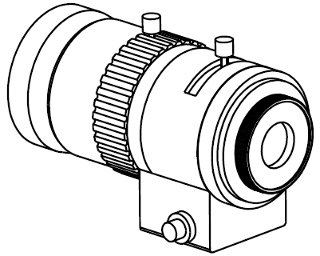
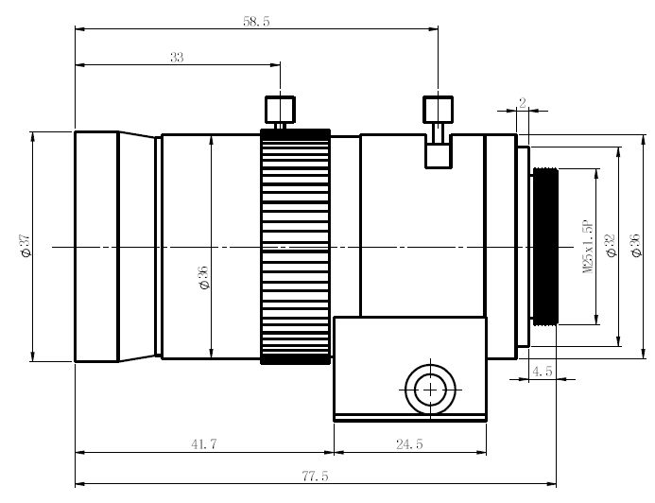

Product Name (型號) |  | V560D-143MPRS
Focal Length (mm) (焦距) |  | (12X) 5-60
Aperture Range (F) (光圈孔徑值域) |  | 1.4~360
Mount (鏡頭座) |  | CS
Imager Size (攝像元件尺寸) |  | 1/2.7”
Angle of View (HOR) (角度) |  | 51°~6.1°
Back Focal Length (mm) (後焦距) |  | 8.1
Coil Resistance (線圈電阻) |  | Drive Coil (驅動線圈) 190Ω  Damping Coil (阻尼線圈) 500Ω
M.O.D. (m) (近攝距離) |  | 1.5
Weight (g) (重量) |  | -
Operation  (操作方式) | Focus (焦距) | Manual (手動)
Operation  (操作方式) | Zoom (變焦) | Manual (手動)
Operation  (操作方式) | Iris (光圈) | Auto Iris (DC) (自動光圈)

